Pricing Quote and Deviation Procedure
Last Updated: Tuesday, July 3rd, 2012
Website Location: http://www.cranecomposites.com/corporateitems/PriceQuote.asp

The Price Quote and Deviation page is an external site for Customer Care and Sales use. The site may be accessed on your work computer, laptop (with or without the VPN), and on mobile devices (Blackberry or iPhone). The site consists of multiple forms that will start by e-mailing the necessary employee(s) and follow with email.

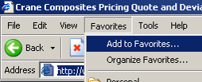
SAVING AND LOCATING THE SITE
To bookmark the folder in Internet Explorer:
- Go to the site listed above
- Click on Favorites, Add to Favorites
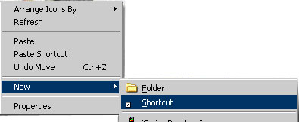
To create a shortcut on your desktop
- Copy the link above
- Go to desktop, click on New - Shortcut
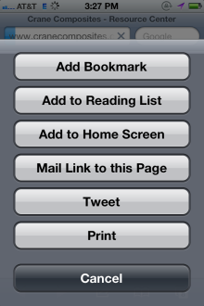
- Past the link in the window,
and click next
- Name the short cut (i.e. Price Quote and Deviation Site), click finish

To create a “Home Screen” on your iPhone
- Send yourself an email. In the subject, copy the link above
- Open the email on your iPhone and click on the link. It will open in Safari
- Open the webpage and tap. Then tap “Add to Home Screen.”
- You will see what the web clip / icon will look like and you can name the icon

USING THE SITE
Price Quote Request Forms
Use to request a price for a product that is not currently listed on a market or customer price list. There are forms for each market. For the Building Products there are four forms (coil/sheet, corrugated, laminated and moldings). Each form is divided into either the Commercial Building Products market or the Retail AND Metal Building Market. There are separate forms for Transportation, RV, and International.
Deviation - Request a discount from a market or customer price list or request exceptions from current pricing and/or business rules. There is one form for all markets.

To fill a form out online
- Fill out the appropriate form, all items marked in red are mandatory. The form will not allow you to continue if those fields are not filled out
- Once you hit submit, you will receive an email with the information you submitted and the following information
- The Market VP or Sales Manager will approve, decline or alter the request by replying to the email and copying the District Sales Manager, Customer Care Account Specialist and Sales Manager listed on the quote form within 16 business hours. The requester should send the approved email request to Salesforce to save the approval

ADDITIONAL INFORMATION
Out of Office
If a financial analyst, product manager or sales manager will be out of the office, they will need to forward their email or email Kate Stakenas. Include on the email the dates the form needs to be changed and who the form should go to during this time. The forms will then we temporarily changed to be sent to a different individual.

